**NSCI 20100 Neuroscience Laboratory**

**Saccade Metrics**

**BSLC 322, January 22-24, 2020**

**Goals:** In this lab, you will record electro-oculogram (EOG) signals related to saccadic eye movements of different amplitudes. With these data, you will examine the relationships between saccade amplitude, duration, speed and acceleration.

**Reading:** There is no recommended reading for this laboratory.

**Safety:** There is alcohol in skin preparation pads for cleaning the skin before placing the EOG electrodes. Do not let any liquid from the pads get in your eyes. Once the EOG electrodes are installed, keep the leads protected and away from water and electrical sources until they are inserted into the isolation unit. No personal protective equipment (PPE) is required or recommended.

**Data:** You will collect eye position traces for saccades of four different sizes in two opposite directions (left and right). You should collect data separately from both students in each pair (complete data collection from the first student before beginning the second). Clean the EOG electrodes between subjects as described in the procedures.

**Clean up:** When you have finished, you should clean the EOG electrodes as described in the procedures. Quit Matlab and collect any data files from the lab machine. You do not need to log out, reboot or shutdown the computer. Disconnect the electrical equipment so it is in the state in which you found it.

**Lab Report:** Lab reports should be prepared following the general instructions found on the course Canvas site. In preparing your report, you should consider the following:

*Results:* Include in your report one or more figures showing your data. How are your saccades of different sizes related (same duration? same speed? same acceleration? some mixture(s) of these?). Are there specific features in your data that should be interpreted as noise?

*Discussion:* What do your data suggest about the neuronal control of saccades? Is there consistency in speed, acceleration or duration across saccades of different amplitude? Given that load on the eye muscles is constant (the mass of the eye), what can you infer about the forces generated by the eye muscles during saccades of different sizes? Can you provide a rationale for why the oculomotor system might adopt the strategy you see?

**Laboratory Procedures**

***Hardware:***

The hardware configuration you will use to record eye movements is exactly the same as that used for the reaction time lab.

*Recording Equipment:* The hardware and cabling will need to be set up. The small switch on the C-ISO-256 pre-amplifier must be set to 2.5 kHz. The cable from the C-ISO-256 should be connected to left input of the iWorx ETH-256 amplifier (multi-pin DIN input next to the Offset knob – not the BNC input). The initial settings for Channel 1 on the iWorx amplifier should be: “DC” HPF (high-pass filter); “50 Hz” LPF (low-pass filter); and “x10” gain. The iWorx C-ISO-256 pre-amplifier has a fixed internal gain of 400x. The settings on the amplifier are indicated by small red LEDs and are changed by pressing the appropriate black button. You may change these setting to improve the quality of your data, but they should be fixed during data collection from each subject (and included in your lab report). Your calculation of EOG voltage must include the combined amplification of the amplifier (10x typically) and pre-amplifier (fixed at 400x). The settings for Channel 2 are irrelevant.

Use a BNC cable to connect Output 1 of the ETH-256 to a LabJack U6 computer data acquisition unit. A BNC-to-wire adaptor will need to be installed to the LabJack’s analog input channel 0 (AIN0, red wire) and analog ground (GND, black wire) inputs and secured by gently tightening the screws to clamp the wires. The LabJack U6 should be connected to the iMac computer with a USB cable.

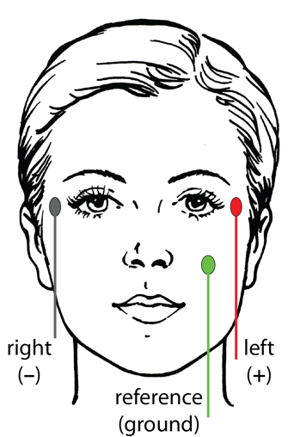*EOG Electrodes*: You will record the EOG using three electrodes. Two active electrodes are positioned immediately lateral to the eyes, but not so close that they interfere with blinking. The remaining reference electrode should be placed on the left check immediately below one eye.

You can put the electrodes on yourself if you prefer, but it is generally faster and easier for you and your partner to put them on each other.

Use an electrode prep pad to gently clean the skin at these three sites. Avoid getting alcohol from the pad in your eyes. Allow the skin to dry completely before attaching the electrodes.

To attach each electrode, lift the blue tab on one sticky pad to lift it and its paper face from backing. Attach the sticky side of the pad to the electrode face. Remove the outer protective paper from the sticky pad and press the pad and electrode on the skin with the wire oriented downward. Once gentle pressure has been applied, the electrode should remain attached. Drape the wire over your shoulder or put it in a shirt pocket to keep it from getting pulled. Attach the remaining two electrodes. Insert a small amount of electrolyte gel inside the electrode using the syringe and blunt needle. Pass the blunt needle through the hole in the electrode and gentle push the plunger until gel starts to come out of the top of the hole.

Plug the electrodes into the C-ISO-256 isolation unit. The jacks are color coded according to the diagram above (red-left, black-right, green-reference). It does not matter if the electrodes you have are different colors, but you should connect them according to this color coding.

***Software:***

You will use a Matlab application to collect your data. The necessary software is installed and configured on each of the lab’s computers. Use the following procedures to run the software.

1) Log into the “labuser” account. There is no password for this account; it should not ask for one. If it does request a password, leave that field blank.

2) Launch Matlab by clicking on the Matlab icon in the dock at the bottom of the display. (Matlab might have a date appended to its name, such as “Matlab_2019b”.)

You will be using two applications in the lab: Oscilloscope and EOG. You must not run them simultaneously. Matlab will let you do this, but it will generate hardware issues. Quit one application before starting the other. You do not need to quit Matlab to go between the applications.

***Signal Assessment:*** Before attempting to collect data, you will use the Oscilloscope application to assess the quality of your signal. You want to see little 60 Hz noise (16.7 ms period) and clear upward and downward deflections of the voltage trace when making large leftward and rightward saccades. You should strive for 60 Hz noise of <50 µV (pre-amplification – after 400x preamplification and 10x amplification you should have 60 Hz noise < 200 mV). You should also familiarize yourself with the consequences of moving the electrode wires, clenching your teeth or blinking while recording EOGs.

3) When it launches, Matlab will display a large, multi-paneled window. You will first measure your 60 Hz noise using an application called “Oscilloscope”, which you can launch by typing its name in the Matlab “Command Window” at the bottom of the Matlab window.

4) The Oscilloscope application will take several seconds to launch. Once it has finished launching, you will see a new window as shown below. When you press the **Start** button, it should begin display the analog signal from the EOG electrodes. You should use this display to minimize the 60 Hz noise (16.7 ms period) on the signal. Large saccades to the left or right should produce vertical deflections that are much larger than any noise. If you are wearing the electrodes, you can see the signal by holding your gaze fixed on the display window while rapidly rotating your head to the left and right (thereby changes the position of your eyes in their orbits.

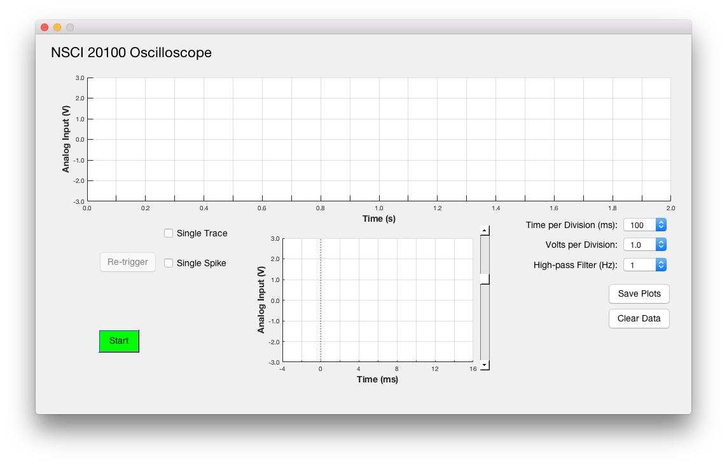

5) When you are satisfied with your signal to noise, you can terminate the Oscilloscope application by closing the EOG control panel window using its close button (red button in the upper left corner). Leave Matlab running. You will need it for collecting data

***Running the EOG Task***

Launch the EOG application by typing its name in the Matlab command window. It will take several seconds to launch, and it will display warnings in the Matlab “Command Window” and the display window that is created on the screen. You can safely ignore all these warnings. Once the EOG application has finished launching, you will see two new windows, which are described below.

../../Screen%20Shot%202017-12-11%20at%2018.30.33.png

The stimulus display will appear as a long, thin horizontal dark gray window at the bottom of the monitor. The control/display panel will appear above and to the right. You should familiarize yourself with the controls and displays and run test trials before you start collecting data you plan to use. You can clear any test data before you start any serious data collection.

The task involves following the small white dot with your eyes. At regular intervals, the white dot will jump left or right at random by 5°, 10°, 15° or 20°. You should simply do your best to keep your gaze on the dot. It is not important that you have a fast reaction time, but you should shift your gaze to follow the dot shortly after it moves. It is important that you do not look away from the dot while you are collecting data. For this reason, you will want to pause and restart your data collection frequently.

**Settings:** Before collecting data, you must adjust the task settings. You must enter the **Viewing Distance**. To set the viewing distance, find a comfortable viewing position and measure the approximate distance from your eyes to the screen. This should generally be 50 to 75 cm. You must enter this value before data collection to ensure that the stimulus steps are calibrated.

The application has a digital notch filter that will remove frequencies close to 60 Hz from the position trace and velocity traces. You will typically get better data with this filter turned on (using the **Filter 60 Hz** checkbox).

You should adjust the **Saccade Threshold** so that you reliably detect most of the small saccades without allowing fluctuations in the noise to be counted as saccades. It is better to miss some saccades than to include spurious signal fluctuations as saccade.

**Saccade Detection:** The application finds saccades using the following approach. A saccade is detected when the position trace first crosses the **Saccade Threshold** after the stimulus step. Five consecutive values (sampled at 1 kHz) above the threshold are counted as the start of a saccade. (If not enough trials have been run for the application to establish a calibration, it will assume that the maximum voltage in the trace corresponds to the stimulus step size on that trial.) When the threshold is crossed, the application will search back in time to the point where the velocity became positive (relative to the direction of the saccade), and count that as the start of the saccade. It will then search forward in time to the first position maximum, and count that as the end of the saccade. The start and end of a detected saccade are marked with vertical dotted lines in the most recent position and velocity traces (plots 1 and 3). These will not appear when no saccade is detected. The time of the stimulus step is marked with vertical the dash-dotted line these plots.

**Breaks**: You should take frequent breaks, but you should not leave the task running when you pause. You should be tracking the spot with your eyes whenever the task is running. You can use the **Start/Stop** button to toggle the task run state. For convenience, you can also use the space bar to toggle the run state if the control panel is front-most. This allows you to pause the task without looking at the control panel.

**Controlling the EOG Task**



The following controls are found at the bottom left of the Control Panel.

**Start (Stop):** Toggle whether the task is running. You can also use the space bar when the control window is front-most.

**Viewing Distance (cm):** The distance from your eyes to the screen. This value must be set before data collection to ensure that your position and speed measures are properly calibrated.

**Saccade Threshold (deg):** The program detects the start and end of each saccade using a movement threshold. You can adjust that threshold here. If your filtered trace is noisy, you will need to set the threshold higher to avoid spurious detections. If your filtered traces are less noisy, you can set the threshold lower to get more precise measurements of the saccade dynamics.

The following displays are plotted in the control/display panel:

**1) Most recent position trace:** The most recent position trace is displayed. The difference between the two EOG electrodes is plotted as a function of time. Rightward and leftward eye movements correspond to up (positive) and down (negative) on this and other displays. A dotted-dashed line marks the stimulus movement. If a saccade is detected, its duration will be marked by vertical lines. Each trace is offset vertically so that the average of the pre-movement portion of the trace lies at y = 0 V. In this and all other time plots, colors correspond to the size of the target step.

**2) Average position traces:** A separate average is computed for each of the four target step sizes and two directions. Before averaging, individual traces are offset so that the pre-saccadic period lies at y = 0 V, and the estimated start of the saccade is aligned at t = 0 s. The y axis is scaled in degrees by assuming that the average post-saccadic position is offset from 0 by the size of the target step. If no saccade is detected on a given trial, that trace will not be included in the average.

**3) Most recent velocity trace:** The most recent velocity trace is displayed. This curve is the derivative of the most recent position trace plotted in panel 1. Calibration is in V/s until enough traces have been collected to establish a voltage-to-position calibration, after which it is plotted in units of deg/s. Horizontal lines mark the saccade threshold for leftward and rightward saccades. Vertical lines mark the stimulus step and the duration of any detected saccade.

**4) Average velocity traces:** A separate average is computed for each of the four target step sizes and two directions. These curves are based on the derivatives of the traces that were used to compute the average position traces in panel 2.

**5) Saccade duration versus amplitude:** Saccade duration in milliseconds is plotted as a function of the four saccade amplitudes in a box format (whiskers have been omitted from this box-and-whisker plot). There is no uniform standard for box plots. You should refer to the Matlab documentation for a description of how these box plots should be interpreted: <https://www.mathworks.com/help/stats/boxplot.html>

**Clean up:** When you have finished collecting and saved your data, you can terminate the EOG application by either 1) closing the EOG control panel window using its close button (red button in the upper left corner), 2) closing the Matlab window using its close button, or 3) making Matlab quit using Quit in the File Menu (or the keyboard equivalent, command-Q). In any case, you will be asked whether you are sure you want to quit. All unsaved data will be lost when you quit.

Immediately after removing the EOG electrodes, wash out the gel or cream using distilled or deionized water. Do not use tap water. A cotton swab can be used to remove the main bulk of the gel or cream. Do not scratch the metal surface of the electrode. You can remove any gel from your face with a wet paper towel.